PROJECT DOCUMENTATION
PROJECT OVERVIEW
The objective of this project is to build a predictive model that determines whether an individual earns more than $50,000 per year based on a variety of demographic and work-related attributes.
TOOLS USED
- MS Excel
- Power BI
DATASET
- Source:https://www.kaggle.com/datasets/mosapabdelghany/adult-income-prediction-dataset
- Dataset contains contain 15 columns with mix of both categorical and numerical features such as age, education, occupation, race, final weight, income etc.
STEPS FOLLOWED
- Cleaned data in Excel (handled missing values, formatted columns etc.)
- Imported cleaned data into Power BI.
- Changed datatypes accordingly.
- Created calculated columns, measures and tables.
- Built dashboards using charts, cards, slicers etc.
KEY INSIGHTS
- The target income is over $50,000 per year.
- It is mainly achieved by individuals aged 40–49.
- These individuals work in the private sector.
- They hold a bachelor's degree.
- Their occupation is executive or managerial.
- They belong to the white racial group.
SCREENSHOT
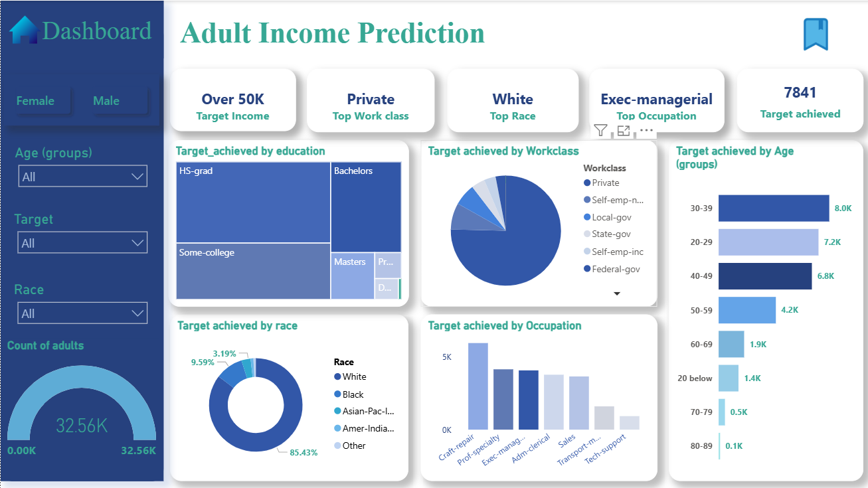

FILES INCLUDED
- https://docs.google.com/spreadsheets/d/1_uod6cDfm4--axck9mPjuytmxvn51iX5/edit?usp=sharing&ouid=114175178653902536766&rtpof=true&sd=true – Cleaned dataset
- https://drive.google.com/file/d/1SM9sibGfOSnYI1JQTC6BXDDyk4lVXzTH/view?usp=sharing – Power BI Dashboard
HOW TO USE
- Open https://docs.google.com/spreadsheets/d/1_uod6cDfm4--axck9mPjuytmxvn51iX5/edit?usp=sharing&ouid=114175178653902536766&rtpof=true&sd=true to view cleaned dataset.
- Open https://drive.google.com/file/d/1SM9sibGfOSnYI1JQTC6BXDDyk4lVXzTH/view?usp=sharing to view Power BI Dashboard.

